Add guest users to the directory

To add B2B collaboration users to the directory, follow these steps:

1. Sign in to the [Azure portal](https://portal.azure.com/) as an Azure AD administrator.
2. In the navigation pane, select **Azure Active Directory**.
3. Under **Manage**, select **Users and groups** > **All users**.
4. Select **New guest user**.

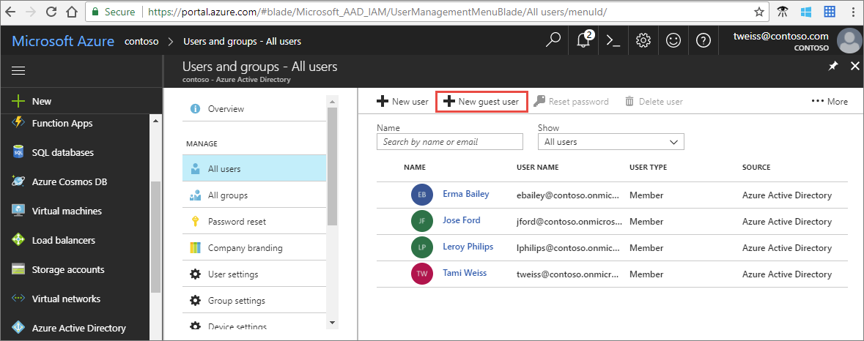

1. Under **Invite a guest**, enter the email address of the external user. Optionally, include a welcome message. For example:

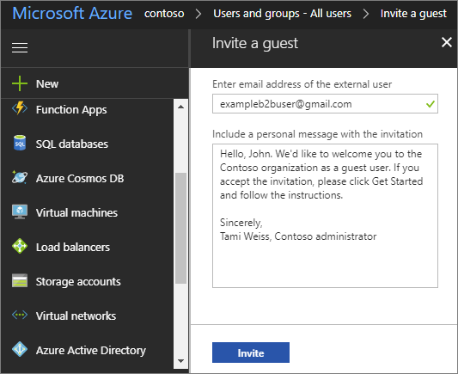

1. Select **Invite** to automatically send the invitation to the guest user. In the **Notification** area, look for a **Successfully invited user** message.

After you send the invitation, the user account is automatically added to the directory as a guest.

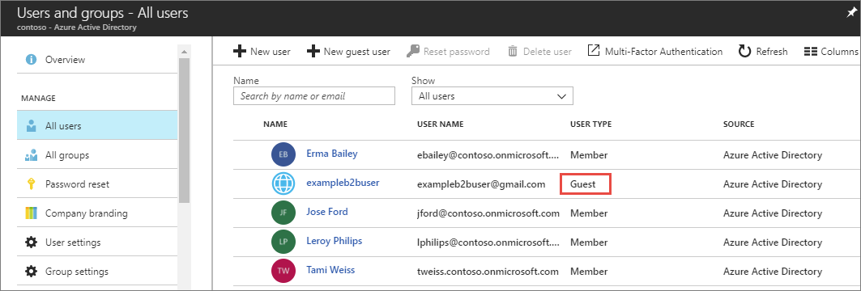

Add guest users to a group

If you need to manually add B2B collaboration users to a group as an Azure AD administrator, follow these steps:

1. Sign in to the [Azure portal](https://portal.azure.com/) as an Azure AD administrator.
2. In the navigation pane, select **Azure Active Directory**.
3. Under **Manage**, select **Users and groups** > **All groups**.
4. Select a group (or click **New group** to create a new one). It's a good idea to include in the group description that the group contains B2B guest users.
5. Select **Members** > **Add members**.
6. Do one of the following:
   * If the guest user already exists in the directory, search for the B2B user. Select the user > click **Select** to add the user to the group.
   * If the guest user does not already exist in the directory, select **Invite**. 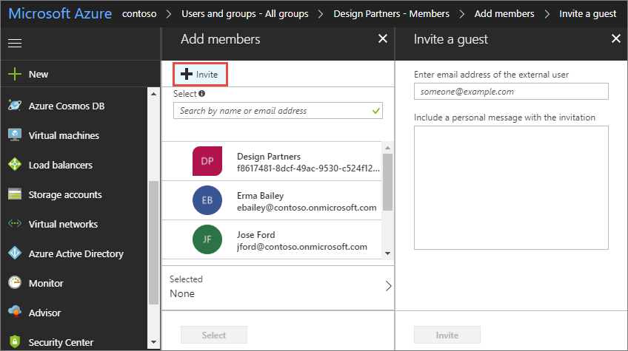

Under **Invite a guest**, enter the email address, and an optional personal message > select **Invite**. Click **Select** to add the user to the group.

The invitation automatically goes out to the invited user. In the **Notification** area, look for a successful **Invited user** message.

You can also use dynamic groups with Azure AD B2B collaboration. For more information, see [Dynamic groups and Azure Active Directory B2B collaboration](https://docs.microsoft.com/en-us/azure/active-directory/active-directory-b2b-dynamic-groups).

Add guest users to an application

To add B2B collaboration users to an application as an Azure AD administrator, follow these steps:

1. Sign in to the [Azure portal](https://portal.azure.com/) as an Azure AD administrator.
2. In the navigation pane, select **Azure Active Directory**.
3. Under **Manage**, select **Enterprise applications** > **All applications**.
4. Select the application to which you want to add guest users.
5. Under **Manage**, select **Users and groups**.
6. Select **Add user**.
7. Under **Add Assignment**, select **User and groups**.
8. Do one of the following:
   * If the guest user already exists in the directory, search for the B2B user. Select the user, and then click **Select** to add the user to the app.
   * If the guest user does not already exist in the directory, select **Invite**. 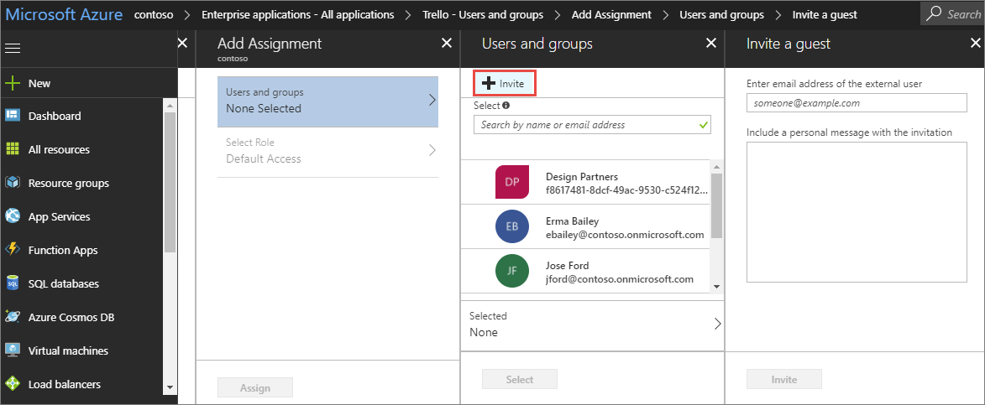

Under **Invite a guest**, enter the email address, and an optional personal message > select **Invite**. Click **Select** to add the user to the app.

The invitation automatically goes out to the invited user. In the **Notification** area, look for a successful **Invited user** message.

1. Under **Add Assignment**, click **Select Role** > select a role to apply to the selected user (if applicable) > select **OK**.
2. Click **Assign**.